PRACTICL NO. 4
Aim: Working with a) operating system services b) Process

Commands :
Command to add and remove services in your system start-up: Use chkconfig -
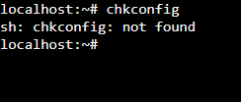
Enter the command to show currently running services ls :
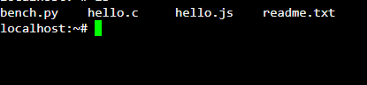
Etc:
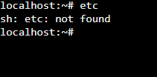
Init.id:
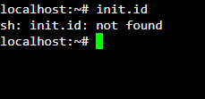

Enter the restart command
Sudo systemctl:
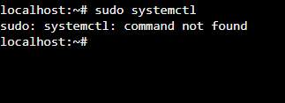

To stop service
Sudo systemctl:

To start service
Sudo systemctl:

PRACTICAL RELATED QUESTIONS:

- List various menus you observed on your system? Ans :
  - Start Menu
  - Taskbar
  - File Explorer
  - System Tray
  - Application Menus
  - Context Menus
  - Browser Menus
  - Application-Specific Menus
  - Terminal Menus
  - Contextual Menus

- Study the GUI of your Linux system.
Ans: The Graphical User Interface (GUI) in Linux allows users to interact with the system using windows, icons, and graphics. It provides a visual environment where you can perform tasks like web browsing, graphic editing, and email. In contrast, the Command Line Interface (CLI) is a text- based interface where you type commands directly into the terminal. In CLI, there are no windows; instead, you receive text-based output. Linux offers flexibility by supporting both graphical and non-graphical modes, allowing users to choose based on their needs. If we use Linux desktop, you’ll likely encounter popular environments like GNOME, KDE each with its own features and tools.

- What is the difference between GUI and CLI. Ans:

GUI | CLI
GUI is easier to understand and use. | CLI is more challenging to  understand and use.
Uses more memory. | Uses less memory.
Provides a lower level of precision. | Offers a higher level of precision.
GUI operates at a slower speed than  CLI. | CLI operates at a higher speed than  GUI.
GUI provides menus. | CLI does not provide menus.
GUI's appearance can be changed or  modified. | CLI's appearance cannot be changed  or modified

